PSSI Science Project Reporting Template

️ | The PSSI Implementation Team is compiling a technical report to demonstrate the important research and advancements made by the Science Branch through the PSSI funding. The technical report will include a 3-4 page summary (including graphics and figures) for each project to show their key results and findings. Please fill in the following fields and sections for your project to be included in the report. Feel free to include and draw from any reports or presentations previously created through your research.  A plain language science bulletin will also be created to follow up on last year’s “DFO Pacific Region Science Bulletin, 2024. New research and monitoring for Pacific salmon and their ecosystems.” While the first bulletin introduced project backgrounds, methods, and timelines, this new bulletin will highlight the projects’ results, key findings, and conclusions with links to reports and data available. The bulletin will include a 1-2 page summary for each project gleaned from the content entered below.  ️ Completed forms are due January 7, 2026.  *Please include or send separately any graphics or pictures (with photo credits) that will help promote the projects.

PART 1: PROJECT METADATA

General Project Information
Project ID (number) | Project Title
2447 | Innovative Ecosystem Based Approaches to identify cumulative stressors: Salmon Fit-Chips and eDNA
Project Leads | Collaborations and External Partners
Kristi Saunders (retired), Christoph Deeg, Arthur Bass, Carl Llewellyn | PSSI - Follow the Fish
Location (if applicable) | PSSI - Follow the Fish
WCVI sounds | PSSI - Follow the Fish

Geographic and Stock Information
Salmon species (if applicable) | Waterbodies (if applicable)
Chinook salmon | WCVI sounds
Life history phases (if applicable) | Region
Early marine | WCVI
Stock (if applicable) | Population (if applicable)
WCVI | Click or tap here to enter text.
Conservation Unit (if applicable)
SWVI, NootKy, NWVI

🧰 PART 2: PROJECT METRICS

Project Outputs
Include any anticipated outputs denoted as (in progress). Please include links to any outputs available online so they can be referenced in the report.
List scientific publications and technical reports (with links)
Anticipated outputs:
- Follow the Fish microtrolling and purse seine reports
- Peer-reviewed publication on Tenacibaculum maritimum on WCVI
- Peer-reviewed publication on WCVI Chinook Fit-Chips describing stressors and disease during first ocean year (pending continued employment)
- Peer-reviewed publication on WCVI ecosystems via environmental DNA (pending continued employment)
- Peer-reviewed publication on WCVI harmful algae impact on juvenile Chinook in collaboration with Andrew Ross (pending continued employment)
- Peer-reviewed publication on WCVI Chinook prey based on stomach contents, zooplankton collection and environmental DNA (pending continued employment)
- Integrated RAMS2 on WCVI Chinook (pending continued employment)
List datasets generated (with links)
- FTF Salmon Fit-Chip dataset (on genomics database until March 31st, 2026)
- WVCI eDNA qPCR dataset covering spatiotemporal patterns of pathogens and salmon along WCVI (on genomics database until March 31st, 2026)
- WCVI eDNA metabarcoding dataset covering spatiotemporal patterns of vertebrates, cephalopods, bony fish, salmon, rockfish, zooplankton, and harmful algae (2116 species on genomics database until March 31st, 2026)
- 724 CTD casts available on Water properties Cruise IDs 2024-087 2025-087
Describe dataset locations and data management systems
Datasets are stored on the genomics program PostgreSQL database maintained until March 31st2026
List code, programs, or other software created (with links)
eDNA pipeline: https://github.com/ViralChris/eDNA_metabarcoding_pipeline_V2
List communication or social media products
Follow the Fish Newsletter V2: https://publications.gc.ca/site/archivee-archived.html?url=https%3A%2F%2Fpublications.gc.ca%2Fcollections%2Fcollection_2025%2Fmpo-dfo%2FFs141-15-2025-2-eng.pdf

List and describe field work completed
- Fit-Chip salmons were collected as non-lethal gill clips (n > 7500) from the Follow the Fish program
- 856 eDNA samples were collected from five WCVI sounds at 131 sites between May 2023 and November 2025 by the genomics program
List and describe samples collected/analyzed (number of samples)
- >7500 gill samples were run on the Fluidigm BioMark high throughput qPCR platform
- 856 eDNA were collected and analyzed on the Fluidigm Biomark platform
- 856 eDNA samples were analyzed by metabarcoding targeting vertebrates, cephalopods, bony fish, salmon, rockfish, zooplankton, and harmful algae
List and describe large capital assets or equipment acquired
NA

PART 3: WRITTEN CONTENT

Highlights
Please summarize in 2-3 bullets:
- The main idea of the project
- Key findings
- Implications of these findings for salmon and decision-makers
- For a more technical audience, but still as plain language as possible
- Idea: This project uses advanced molecular tools to evaluate the cumulative effects of environment and individual condition on juvenile Chinook salmon in their ocean entry year (OEY). This is done directly on the individual level by assessing stress and infectious agents in fish using salmon Fit-Chip on minimally invasive gill biopsies as well as on ecosystem level by assessing community composition from salmon pathogens to predators by analyzing concurrent environmental DNA samples.
- Key findings:
  - Fit-Chips
    - Multiple factors, including thermal stress, hypoxia, and several infectious agents, were associated with survival impacts in the OEY for Chinook salmon
    - Thermal stress, the occurrence of which we expect will increase with climate change, was common in Barkley Sound in July and August, and may occur in other sounds. Our data and many previous studies indicate that thermal stress at ocean entry (and/or associated factors) are negatively associated with survival for salmonids.
    - Hypoxia stress was apparent in 25% of OEY fall-winter Chinook salmon
    - The Fit-Chip “food deprivation” panel provided very limited (<2%) evidence of starvation during the study period
    - As “aquaculture pressure” increases, OEY Chinook salmon are more likely to test positive for several infectious agents, some of which were positively associated with imminent mortality.
  - eDNA
    - Community composition across the west coast of Vancouver Island shows spatial differentiation from north to south, but environmental drivers of temperature, oxygen saturation, and salinity have a higher impact that spatial gradients alone and show repeating seasonal patterns.
    - Salmon was associated with annual migration cycles and we were able to highlight key salmon habitat based on reoccurring distribution patterns
    - Analysis of prey and predator distribution suggested that high prey abundances are also associated with high predator abundances. Similarly, many high prey abundance locations also experience high densities of harmful algae bloom (HAB) producing species as well as pathogens. Together this suggest that OEY Chinook salmon must balance feeding opportunities with predation, pathogen, and toxin risks
    - Atlantic salmon aquaculture was positively associated with several pathogens of concern for OEY Chinook as were Chinook themselves. This suggests that Chinook may be attracted to aquaculture sites where they are exposed to pathogens
- Implications
  - Thermal stress and hypoxia already impact OEY Chinook salmon and these impacts are likely to increase as climate change progresses
  - OEY Chinook may be exposed to critical temperature, oxygen, and algae toxins as well as elevated pathogen and predators pressuere when foraging
  - Netpen aquaculture is associated with increased pathogen levels and likely increases pathogen exposure for OEY Chinook salmon in WCVI inlets
  - Prey limitation seems to be a factor of limited impact to OEY Chinook over the assessed time period.

Background
Please provide 1-2 paragraphs to summarize
- The relevant biological, environmental, and/or management context
- What knowledge gap or demand were you trying to fill?
- Collaboration and partner relationships
Natural-origin Chinook salmon in West Coast Vancouver Island (WCVI) inlets have experienced population declines in recent decades, to the extent that some WCVI spawning streams with intact habitat are seeing very low returns of natal fish and are dependent on hatchery strays. A recent WCVI Chinook risk assessment process identified several factors associated with OEY residence that can be examined using molecular tools. These include prey availability, pathogens, harmful algae, predation, high temperatures and hypoxia. We deploy molecular tools to address these factors as part of the “Follow the Fish” (FTF) program (Project 2407), which was a collaborative effort among several DFO scientists, many WCVI First Nations, and several coastal NGOs. Salmon Fit-Chips are a molecular-based method for examining the physiological response to stressors and quantifying pathogens on the level of individual fish from minimally invasive gill biopsies and were deployed on fish collected by the FTF program. Additionally, we collected water samples alongside FTF sampling for e(nvironmental)DNA analysis, where we reconstruct the ecosystem based on the nucleic acids detected in the water. With this data we are able to detect salmon and assess where they interact with salmon pathogens, their prey and predators as well as where they are exposed to harmful algae bloom species.

️ Methods and Findings
Please insert a few paragraphs to summarize:
- Main methods used
- Products and tools produced
- Advancements in methodology, technology, and application
- Advancements in communication and knowledge transfer
- Key results and information generated
Salmon Fit-Chips Methods: Chinook salmon gill biopsies, collected from purse seine, beach seine, and microtroll collections as part of the Follow the Fish project, were run on the Fluidigm Biomark nanofluidic qPCR platform. Within a single analytical run, this platform allows for assays of 13 infectious agents and 70 salmon genes to be run against 80 gill samples, known as a salmon Fit-Chip. The salmon gene expression can be statistically analyzed to provide probabilities (0-1) for certain salmon “stressor states” including: food deprivation, imminent mortality, viral disease, smoltification, hypoxia, inflammation, and immune stimulation. Detailed methods for the Fit-Chip laboratory and statistical analysis can be found in Akbarzadeh et al. (2024).
Because there is no measure of survival for the Follow the Fish project until PIT-tagged adults return over the next few years, we used the “imminent mortality” panel from the Fit-Chips as a proxy for survival. The imminent mortality panel is based on the gene expression of fish that were sampled in the laboratory in a moribund state or within 72 hours of dying, thus fish in the wild that show such a pattern are likely experiencing severe physiological stress, although we are unable to determine their actual fate. Probability of imminent mortality was used as the response variable for a geostatistical model (Anderson et al. 2024) that included all the pathogens detected at adequate prevalence and all of the Fit-Chip stressors. Some confounding factors such as sample year, day of year, capture method, and location were included as predictors or random effects. We ran another geostatistical model with all the same predictor variables but with Fulton’s K (mass relative to length) as the response, with the expectation that skinnier fish are at a physiological disadvantage relative to heavier fish.
For the analysis of infectious agent detections in salmon gill relative to “aquaculture pressure” we once again used geostatistical models where infectious agent copies RNA/DNA was the response variable and aquaculture pressure and confounding variables as mentioned above were the predictors. To determine aquaculture pressure, we used an approach often applied in the sea lice literature, where kernel density weights from active farms were summed for each fish collection location (Nekouei et al. 2018). Where counts of sea lice were multiplied by the kernel density estimate in previous studies, we instead multiplied the farm salmon biomass with the assumption that as biomass increases, the potential for infectious agents to be dispersed away from farms at greater concentrations also increases. We ran these models for both Atlantic Salmon and Chinook salmon farms (only using Clayoquot data for Chinook farms since those only exist in Clayoquot Sound).
Salmon Fit-Chips Products and tools produced / Advancements in methodology, technology, and application
For this study we developed a tailor made dedicated Chinook Fit-Chip to target the most important factors for juvenile WCVI Chinook.
Key Salmon Fit-Chips Findings:
- Very few (<2%) of samples run indicated that Chinook salmon were food-deprived, indicating that food availability might not be a limiting factor, at least in the populations/years/regions represented by our sampling efforts
- Chinook captured in their first Fall-winter in the ocean showed a 25% incidence of hypoxia stress, indicating a substantial proportion of the population is exposed to low oxygen environments
- In Barkley Sound, in July and August of each study year, 30% of Chinook exhibited thermal stress – indicating that they were exposed to elevated water temperatures near the surface. Prevalence of Tenacibaculum maritimum, a bacterium of interest from previous studies, was also close to 100% among fish during this period (Figure 1). These factors combined may represent a particularly high stress period.
- Spatial models where the imminent mortality Fit-Chip panel served as the response variable revealed positive associations between “imminent mortality” and hypoxia, thermal stress, PSNV1, T. maritimum, Ca. B. cysticola, and L. salmonae (Figure 2). Two pathogens, PSNV1 and L. salmonae, were negatively correlated with Fulton’s K (body condition) (Figure 2). The imminent mortality panel and body condition are our best proxies for survival until we have PIT tag returns from the Somass River PIT array.
- In sounds with active netpen aquaculture, there was a positive association between “aquaculture pressure” from Atlantic Salmon farms and the PCR detections (in Chinook salmon gill) of Piscine orthoreovirus 1a, Loma salmonae, Tenacibaculum maritimum, and Ca. Branchiomonas cysticola. For Chinook farms, the association was positive for Pacific salmon nidovirus 1 (PSNV1), Loma salmonae, Ichthyophthirius multifiliis, and Paranucleospora theridion (Figure 3).
- PSNV1 was extremely abundant at two WCVI hatcheries but quickly disappeared as fish entered the marine environment. This pattern is consistent with the virus causing high mortality or being cleared as fish enter seawater.
EDNA Methods: 5L replicate water samples were collected via transect from 8m depth and filtered onboard the research vessel through hollow membrane filters. In total, 856 eDNA samples from 131 sites from all WCVI Sounds were analyzed in this study. Nucleic acids were extracted in a dedicated clean laboratory and quantified. Samples were then analyzed in two separate workflows: First, nucleic acids of key salmon pathogens, salmon, and prominent forage fish were quantified on the Fluidigm Biomark nanofluidic qPCR platform with targeted assays. Second, metabarcoding to elucidate community composition targeting bony fish, salmonids, cephalopods, rock fish, vertebrates, and invertebrates was performed by sequencing. Sequence data were analyzed using a custom-built pipeline. Statistical analysis of both datasets was performed in R. “Aquaculture pressure” was assessed via kernel density as described above.
eDNA Products and tools produced / Advancements in methodology, technology, and application
Custom analysis pipeline: (https://github.com/ViralChris/eDNA_metabarcoding_pipeline_V2)
WCVI eDNA database with >20 billion reads of 2116 operational taxonomic units.
Key eDNA Findings:
- eDNA is a valuable tool to describe the entire ecosystem from viruses to whales and was able to describe the spatiotemporal distribution of numerous species relevant for salmon survival. Key observations contain viruses such as Piscine orthoreovirus 1a, pathogenic bacteria like Tenacibaculum maritimum, key prey items including Euphausiids and herring, all Pacific salmon species, predators of juveniles (auks and rockfish) as well as adults (sealions and dogfish) and even harmful algae species such as Heterosigma akashiwo (Figure 4).
- Community composition along WCVI sounds was influenced by spatial gradients, but seasonal reoccurring trends were overriding these influences. Temperature, salinity, and oxygen concentration were the key environmental drivers of community composition.
- Abundance of prey items of juvenile Chinook showed strong seasonal and inter-seasonal variation (Figure 5). Crucially, high prey abundances were often associated with high predator abundances, pathogens and potentially harmful algae in the summer, suggesting that salmon may subject themselves to hazardous conditions to avail themselves to feeding opportunities (Figure 4). We are currently addressing the impact of harmful algae by combining the eDNA dataset with the toxicological data collected by Dr Andrew Ross under the FTF project.
- Several pathogens of interest were positively associated with Atlantic salmon aquaculture, including Piscine orthoreovirus 1a, Tenacibaculum maritimum, Paranucleospora theridion, Moritella viscosa, Loma salmonae, Ichthyophthirius multifiliis, Ca. Branchiomonas cysticola, Tenacibaculum finmarkense, and Piscricketsia salmonis. Notably, Chinook, Dolly Varden and rainbow trout, all species with a coastal residency in their life history, were also positively associated with Atlantic salmon aquaculture, suggesting that farms attract such salmonids and could lead to pathogen exposure (Figure 6A). Tenacibaculum maritimum was observed at higher concentrations and longer in sounds where salmon net pen aquaculture is practiced (e.g. Nootka and Clayoquot) than in sounds without aquaculture (Barkley) where it occurred primarily in the summer (Figure 6B).

💡Insights
Please insert a few paragraphs to summarize:
- What this project has added to knowledge about salmon populations, health, or ecosystems.
- How this project informs salmon management:
  - decisions
  - policy guidance
  - trade-offs
  - planning
- Addition of knowledge to understanding:
  - limiting factors/stressors/threats/ pathways of effects/risks
  - biologically significant thresholds
  - cumulative impacts
- Sources of uncertainty
This dataset constitutes one of the largest and most comprehensive surveys of stress and infectious agents in Chinook salmon in their first marine year. Many questions in addition to the original goals of the project (and which may not yet be apparent) could be asked of these data. Therefore, the full potential contributions to policy and planning are expected to expand beyond the suggestions below:

Findings from this study are most relevant to policy and planning regarding netpen salmon aquaculture and SEP hatcheries. For SEP hatcheries, the finding of higher hatchery (relative to migrating fish) prevalence of PSNV1, a little-known virus with potential to have negative impacts, provides an opportunity to improve animal welfare and biosecurity, depending upon the outcome of further research on the pathogenicity of PSNV1.

For net-pen salmon aquaculture, our study added to previous work demonstrating that WCVI aquaculture facilities elevate sea lice levels in wild Pacific salmon (Nekouei et al. 2018, Jeong et al. 2025) by providing evidence of a positive association between aquaculture pressure and several infectious agents in free-living Chinook salmon (using similar statistical methods as those sea lice studies). The list of infectious agents associated with netpen aquaculture in seawater detected via eDNA has many commonalities with what was associated in fish - suggesting a causal link between exposure and infection. The combination of these findings suggests that netpen aquaculture elevates parasites and pathogens in the environment and in free-living Chinook salmon, particularly in Clayoquot Sound where netpen aquaculture is abundant and several spawning streams with seemingly pristine habitat are characterized by very poor survival of outmigrant juvenile salmon.

eDNA data showed that salmonids with coastal resident life histories such as Chinook were associated with salmon aquaculture sites, potentially because they are attracted to the high biomass and/or feed off the farms, which could lead to pathogen exposure. Similarly, eDNA data also indicated that while key prey groups were readily detectable, they were patchily distributed in space and time. Juvenile salmon may be forced to expose themselves to harmful algae, pathogens, and predators in order to access prey resources, as these often co-occurred at the same sites.

With research objectives intertwined with the WCVI Chinook risk assessment process, our study contributed significantly to our understanding of limiting factors. While not ruling out the potential for prey availability as a limiting factor, the Salmon Fit-Chip food deprivation panel did not provide evidence that many fish are experiencing sparse prey fields. As demonstrated many times in other studies, we found evidence that sea surface temperature is a limiting factor for WCVI Chinook salmon. Hypoxia also appeared as a limiting factor, perhaps effecting a higher proportion of the population than previously expected.

⏩ Next Steps
Please insert 1-2 paragraphs to summarize:
- Remaining knowledge gaps and recommendations for future studies
- How can/should the project findings be operationalized for salmon conservation and management?
Future Studies:
- The impacts of the various parameters measured by Salmon Fit-Chips will be best evaluated once PIT-tagged adults have returned to the Somass River over the next few years. The Pacific Salmon Foundation and University of Victoria have established a PIT reader in the Somass River and will be applying some of the Salmon Fit-Chip data described in this report to test for associations between factors like thermal stress, hypoxia, and infectious agents and true survival (rather than the probability of imminent mortality).
- As we observed seemingly stressful conditions for Chinook salmon during the summer in Barkley Sound, it would be important to know whether or not these conditions occur in all WCVI inlets. Repeating the purse seine sampling program in Clayoquot and Nootka Sounds during the summer months would be highly informative.
- Further research into the Pacific Salmon Nidovirus 1, most likely in the form of controlled laboratory challenge studies, would provide vital information regarding this little-known virus. PSNV1 appeared to be positively associated with imminent mortality and negatively associated with body condition. We know from this study and others that this virus reaches very high prevalence in hatcheries but is rarely observed in the wild, particularly in the marine environment. Knowing whether the disappearance of the virus in marine waters is due to clearance or mortality would indicate whether or not mitigation at hatcheries is required.
- Several infectious agents were positively associated with aquaculture pressure. Future studies that investigate potential impacts of those pathogens on natural-origin fish would be valuable since aquaculture management is one of the few “levers that can be pulled” on a relatively short timescale.
- Current eDNA work is focuses on completing the sample analysis (estimated time of completion Mid-February 2026) and final statistical analysis of the complete dataset (estimated time of completion March 2026)
- Collaboration with the otolith microchemistry group (Nicole LaForge, Micah Quindazzi) will allow for investigation of the carry over effects and other impacts of different Chinook juvenile life history types through the lens of Fit-Chip stressor panels and pathogens.
- Collaboration with Andrew Ross’ group under FTF will merge eDNA data on harmful algae with algae toxin levels measured in water and salmon tissues to create a complex framework for algae toxin exposure risks in juvenile Chinook
- Collaboration with Akash Sastri and Kelly Young under FTF will merge eDNA data on zooplankton species with conventional zooplankton survey data by analyzing sequence data on physical composition
- In collaboration with Tim Healy’s group, we will utilize age specific methylation markers to determine the age composition of Chinook salmon eDNA detections in order better understand the specific habitat usage criteria of juvenile and adult Chinook

Applying study results to salmon conservation and management:
- The data and results from this project will be used to inform the WCVI Chinook Marine Risk Assessment process. It will also feed into additional studies (otoliths, biotoxins, plankton) that will further inform the Risk Assessment.
- Our data provides further evidence-based data on the impact of open net-pen salmon aquaculture on wild salmon and supports “the implementation of a ban on open net-pen salmon aquaculture in B.C. coastal waters by June 30, 2029,” as committed to in official Canadian government policy (Government of Canada 2024: https://ised-isde.canada.ca/site/ised/en/draft-salmon-aquaculture-transition-plan-british-columbia).
- Cumulative stressors throughout the summer, such as temperature, hypoxia and pathogen loads (specifically Tenacibaculum spp.) could be integrated into the management of recreational fisheries to minimize mortality from catch and release practices during critical times (Hinch et al 2024).

📈 Tables and Figures
Please provide captions and numbering for any tables and figures. Graphics can be copied below or e-mailed separately.
- Include a brief caption with each figure and table in the box below
- Number each table and figure, and include references in the above sections where appropriate.
- 1-3 figures are recommended per project
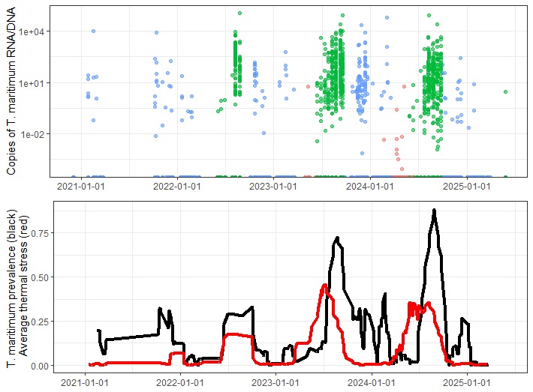
Figure 1: Tenacibaculum maritimum was prevalent in ocean entry year Chinook salmon collected in July and August each study year in Barkley Sound, and the period when infections rapidly increased coincided with thermal stress as revealed by Salmon Fit-Chips. Top panel: each point represents an individual Chinook salmon captured by beach seine (red), purse seine (green), or microtroll (blue) in Barkley Sound. Points at bottom of y-axis indicate non-detections. Bottom panel: Daily prevalence of T. maritimum (black line) and averaged daily probability of thermal stress (red line). Both are averaged over adjacent 10 days to smooth for presentation.
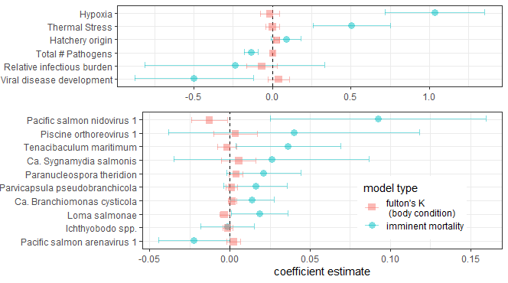
Figure 2: Model results from geostatistical models of imminent mortality and body condition. If blue points and associated 95% confidence intervals are entirely to the right of the vertical dashed line, that variable is positively associated with the probability of imminent mortality, where as to the left of the line would indicate a negative association. If red points and associated 95% confidence intervals are entirely to the left of the vertical dashed line, that variable is negatively associated with body condition, indicating high levels of that variable are associated with skinnier fish. Note the different scales (x-axis) of the two plots.

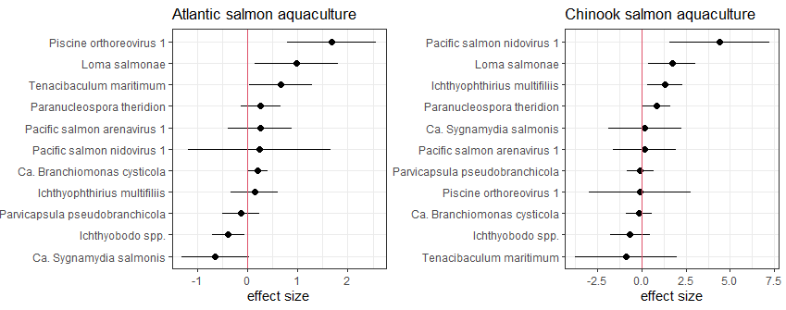
Figure 3: Aquaculture pressure (Atlantic Salmon farms left, Chinook salmon farms right) was positively associated with copy number of several infectious agents in microtroll-caught Chinook salmon in WCVI inlets. Each row represents a geostatistical model where pathogen copy number was the response variable.
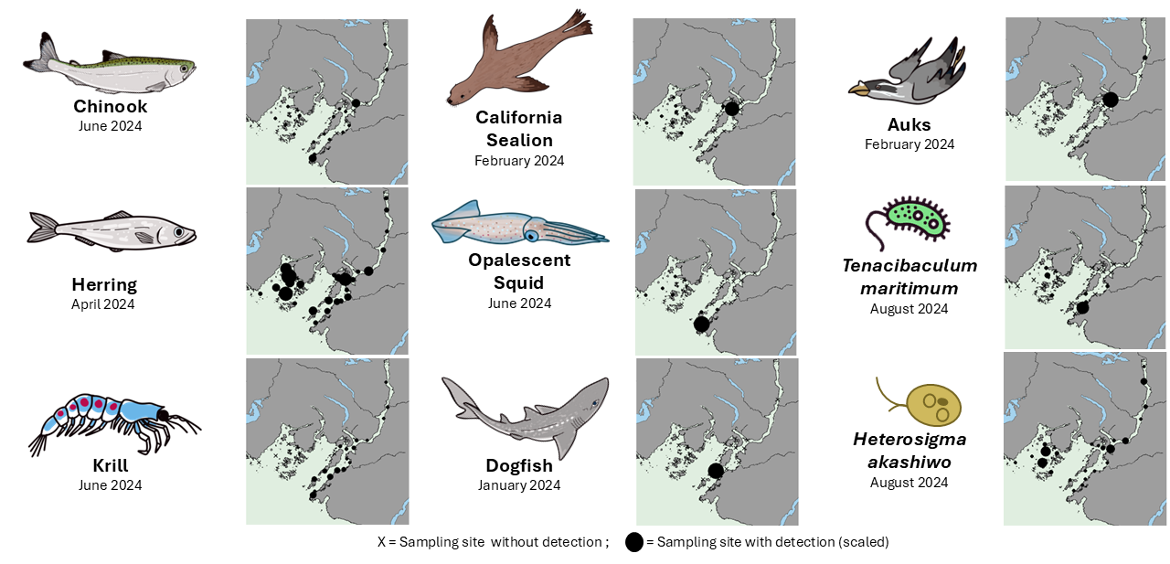
Figure 4: Community composition of Barkley Sound in Summer 2024: Selected species detected by eDNA shown in proportionally scaled circles. ”X” represents samples collected without detection of the respective species.

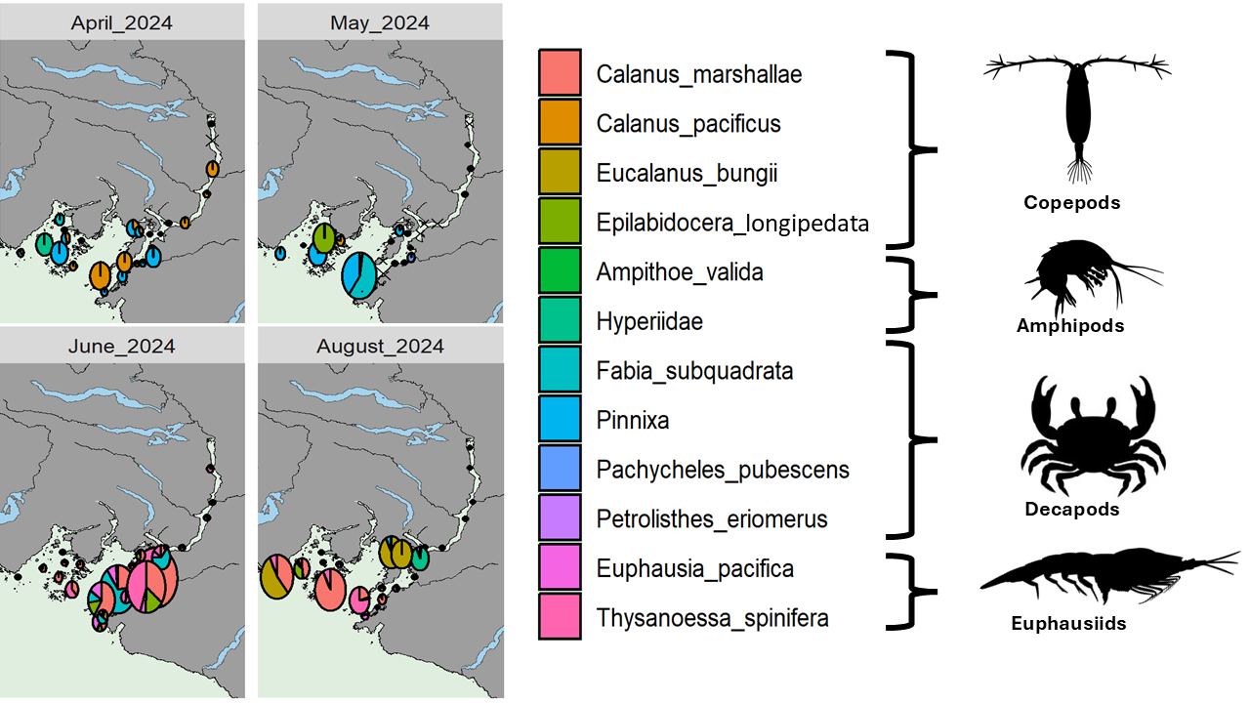Figure 5: OEY Chinook early marine prey species relative abundance and composition in Barkley sound during spring and early summer 2024 before they transition to piscene prey (Aproximatley in July to August). Prey sources are spatotemorally heterogeniously distributed. Alberni Inlet represents as a prey depletd region throughout spring.
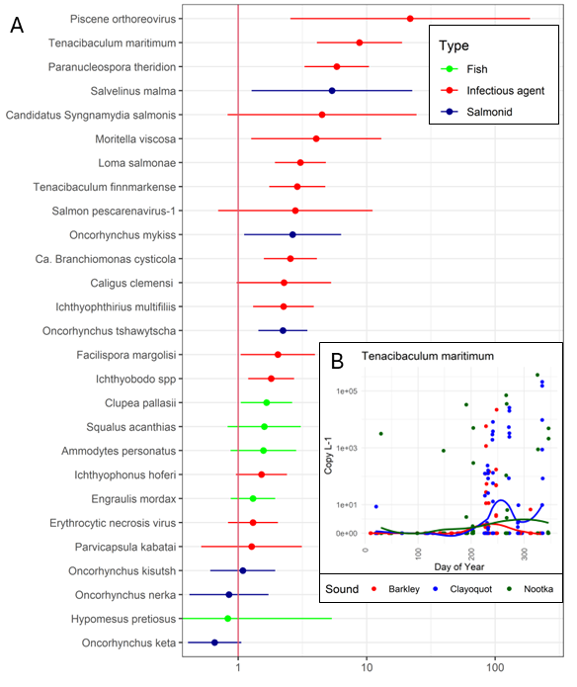
Figure 6: eDNA detections and salmon aquaculture: A: Atlantic Salmon quaculture (detection of Atlantic salmon in eDNA) was positively associated with copy number of several infectious agents in eDNA in WCVI sounds. Each row represents a geostatistical model where pathogen copy number was the response variable. B: Time of year and quantity of detection of Tenacibaculum maritimum in the eDNA dataset per Sound. Salmon aquaculture is not found in Barkley sound. Every data point repesents a sample and a trend line is added.

📈 References
Include full references for any publications referenced in other sections. Please format references in Harvard style according to Instructions to Authors for the Canadian Journal of Fisheries and Aquatic Sciences, at Canadian Science Publishing.
Akbarzadeh A, Ming TJ, Schulze AD, Kaukinen KH, Li S, Gunther OP, Houde ALS, Miller KM (2024) “Developing molecular classifiers to detect environmental stressors, smolt stages and morbidity in coho salmon Oncorhynchus kisutch.” Science of the Total Environment, 951(15). https://doi.org/10.1016/j.scitotenv.2024.175626

Anderson SC, Ward EJ, English PA, Barnett LAK, Thorson JT (2024). “sdmTMB: an R package for fast, flexible, and user-friendly generalized linear mixed effects models with spatial and spatiotemporal random fields.” bioRxiv, 2022.03.24.485545. doi:10.1101/2022.03.24.485545.

Hinch, S.G., Johnston, S.D., Lunzmann-Cooke, E.L., Zinn, K. and Hendriks, B.J.L., 2024. Enhancing the sustainability of capture and release marine recreational Pacific salmon fisheries using new tools and novel technologies. Final Report on Project 2019_058 submitted to the British Columbia Salmon Restoration and Innovation Fund.

Nekouei, O., Vanderstichel, R., Thakur, K. et al. Association between sea lice (Lepeophtheirus salmonis) infestation on Atlantic salmon farms and wild Pacific salmon in Muchalat Inlet, Canada. Sci Rep 8, 4023 (2018). https://doi.org/10.1038/s41598-018-22458-8

Jeong J, Price D, Jones S, Johnson S, Weber L, Parsons GJ. Spatiotemporally dependent relationship between salmon lice from salmon farms and infestation on juvenile pacific salmon in british columbia, canada. Aquaculture Environment Interactions 2025;17:119-36.

